MODERN WARFARE

Even as the Allies celebrated victory, the appalling costs of the war began to emerge. It had killed as many as 75 million people around the world. In Europe, about 38 million people had lost their lives, many of them civilians. The Soviet Union suffered the worst casualties, with more than 22 million dead.
Numbers alone did not tell the story of the Nazi nightmare in Europe or the Japanese brutality in Asia. In the aftermath of war, investigation brought atrocities to light.

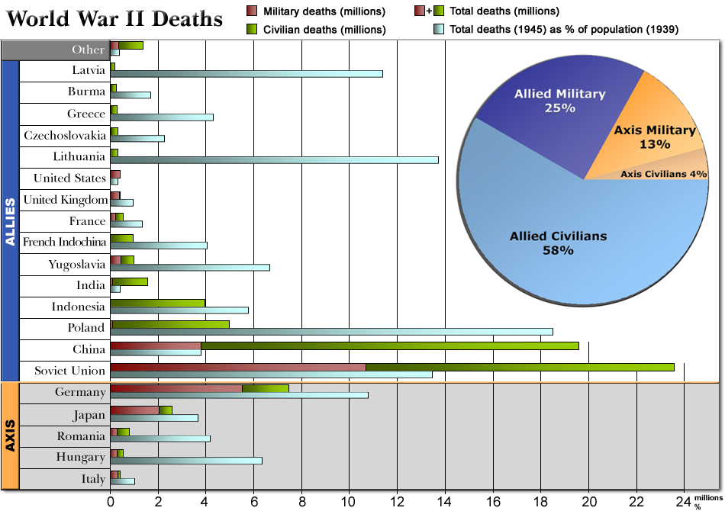

THE HOLOCAUST

During the war, the Allies were aware of the existence of concentration camps and death camps. But only at war’s end did they learn the full extent of the inhumanity and misery. Walking skeletons stumbled out of the death camps with tales of mass murder. Rudolf Hoess, a Nazi commander at Auschwitz, would later admit that he had supervised the killing of some 2.5 million people.
At wartime meetings, the Allies had agreed that Axis leaders should be tried for “crimes against humanity.” In Germany, the Allies held war crime trials in Nuremberg, where Hitler had staged mass rallies in the 1930s. A total of 177 German and Austrians were tried, and 142 were found guilty. A handful of top Nazis received death sentences. Others were imprisoned. Similar war crimes trials were held in Japan and Italy. The trials showed that political and military leaders could be held accountable for actions in wartime.
The war crimes trials served an additional purpose. By exposing the savagery of the Axis regimes, they further discredited Nazi, fascist, and militarist ideologies.
Questions also haunted people. What made the Nazi horrors possible? Why had ordinary people allowed this to happen? How could the world prevent the rise of future dictators?
The Allies tried to address those issues tried to address those issues as their troops occupied Germany and Japan. The U.S. felt that strengthening democracy would ensure tolerance and peace. They even replaced Nazi textbooks and courses with new curriculum that taught democratic principles.

PREVENTING FUTURE WARS

As in 1919, the World War II Allies set up an international organization to ensure peace. In April 1945, delegates from 50 nations met in San Francisco to draft a charter for the United Nations. The UN would play a greater role in world affairs than did its predecessor, the League of Nations.
Under the UN charter, each of the member nations had one vote in the General Assembly. A much smaller body called the Security Council was given greater power. Each of its five permanent members (the U.S., the Soviet Union, Britain, France, and China) had the right to veto any council decision. The goal was to give these great powers the authority to ensure the peace. Often, however, differences among these nations have keep the UN from taking action.
The UN’s work would go far beyond peacekeeping. The organization would take on many world problems-from preventing the outbreak of disease and improving education to protecting refugees and aiding nations to develop economically. UN agencies like the World Health Organization and the Food and Agricultural Organization have provided help for millions of people around the world.

ALLIANCES FALL APART

During the war, the Soviet Union and the nations of the West had cooperated to defeat Nazi Germany. By 1945, however, the wartime alliance was crumbling. Conflicting ideologies and mutual distrust soon led to the conflict known as the Cold War. The Cold War was a state of tension and hostility among nations, without armed conflict between the major rivals. At first the focus of the Cold War was Eastern Europe, where Stalin and the western powers had different goals.
Stalin had two goals in Eastern Europe. First, he wanted to spread communism into the area. Second, he wanted to create a buffer zone as a defense against Germany.
As the Red Army had pushed German forces out of Eastern Europe, it had left behind occupying forces. At wartime conferences, Stalin tried to persuade the West to accept Soviet influence in Eastern Europe. The Soviet Union pointed out that the U.S. was not consulting the Soviet Union about peace terms for Italy or Japan. In the same way Russia would determine the fate of Eastern Europe.
Roosevelt and Churchill rejected Stalin’s view, making him promise “free elections” in Eastern Europe, but Stalin ignored the pledge. By 1948, Stalin had installed pro-Soviet communist governments throughout Eastern Europe.
Churchill had long distrusted Stalin. As early as 1946, during a visit to the U.S., he described the Soviet control of Eastern Europe as an “iron curtain” dividing the continent. In the West, the “iron curtain” became a symbol of the Cold War. It expressed the growing fear of communism. More importantly, it described the division of Europe into “eastern” (communist) and “western” (democratic) blocs.

MISTRUST OF THE SOVIETS AND COMMUNISM

Like Churchill, President Truman saw communism as an evil force creeping across Europe and threatening countries around the world. To deal with that threat, the U.S. abandoned its traditional isolationism. After WWII, the nation took a leading role on the world stage.
Truman took action against aggressive Soviet actions. On March 12, 1947, Truman issued the Truman Doctrine. It stated that the Americans would resist Soviet expansion in Europe and anywhere else in the world. Truman sent military and economic aid and advisers to Greece and Turkey to deal with the communist threat. The Truman Doctrine was rooted in the idea of containment, limiting communism to the areas under Soviet control.
The U.S. also offered a massive aid package, called the Marshall Plan. Under it, the U.S. funneled food and economic assistance to help European countries rebuild. Stalin forbade Eastern European countries to accept the aid as he saw it as a trick to win countries over to capitalism and democracy.
Tensions quickly grew in Europe. In 1949, the U.S., Canada, and nine Western European countries formed a new military alliance called the North Atlantic Treaty Organization (NATO). In 1955, the Soviet Union responded by creating the Warsaw Pact. It included the USSR and seven satellites in Eastern Europe.
Both sides participated in a propaganda war. The U.S. spoke of defending capitalism and democracy. The Soviet Union claimed the moral high ground in the struggle against western imperialism.

DEALING WITH NAZI GERMANY

Defeated Germany became another focus of the Cold War. Fearing the danger of a restored Germany, the Soviet Union dismantled the factories and other resources in its occupation zone and use them to rebuild Russia. France, Britain, and the U.S., however, decided to unite their zones of occupation, encouraging German to rebuild businesses and industries.
Germany thus became a divided nation. In West Germany, the democratic nations allowed people to write their own constitution and regain self-government. In East Germany, the Soviet Union installed a communist government tied to Moscow.
By 1948, Stalin tried to force the western Allies out of Berlin by sealing off every railroad and high way into the western sectors of the city. The western powers responded to the blockade by mounting a round-the-clock airlift. For more than a year, cargo planes supplied West Berliners with food and fuel. Their successes forced the Soviets to end the blockade.

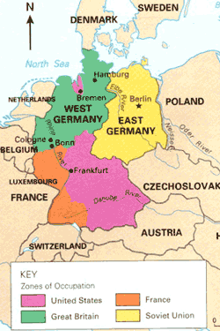

THE USE OF THE ATOMIC BOMB

Each side in the Cold War armed itself to withstand an attack by the others. At first, the United States held an advantage in its control of nuclear power. But Stalin’s top scientists were under orders to develop an atomic bomb of their own. They succeeded in 1949, and the arms race was on. For four decades, the superpowers spent fantastic sums of money to develop new, more deadly nuclear and conventional weapons. They invested still more to improve “delivery systems”-bombers, missiles, and submarines to launch these weapons of mass destruction. Soon the global balance of power became in Churchill’s phrase, “a balance of terror.”
