A Declining Empire:
In 1800, the Hapsburgs were the oldest ruling family in Europe. They ruled over Austria, Bohemia, Hungary, and parts of Romania, Poland, Ukraine and Northern Italy. Austrian Emperor Francis I and his foreign minister Metternich upheld conservative goals. However, they could not avoid industrialization.
The Hapsburgs ruled over a multinational empire. Fewer than ¼ of its population were German-speaking Austrians. The rest were Slavic groups including: Czechs, Slovaks, Poles, Ukrainians, Romanians, Serbs, Croats, and Slovenes. It also included a number of Hungarians and Italians. Many of these groups wanted nationalism, causing tension within the Empire.
An 18-year old, Francis Joseph inherited the Hapsburg throne. Francis Joseph tried to strengthen the Hapsburg Empire. He made limited reforms such as granting a new constitution which set up a legislature. However, this legislature was dominated by Austrians and the other nationalist groups demanded self-government.

What was the cause of tension within the Hapsburg Empire?
The Dual Monarchy
Austria’s defeat against Prussia brought pressures to change. Francis Deak, a moderate Hungarian leader, helped make a compromise that created a new political power known as the Dual Monarchy of Austria-Hungary. Under the agreement, Austria and Hungary were separate states. Each had its own constitution and parliament. Francis Joseph ruled both, as emperor of Austria and king of Hungary.
Hungarians welcomed the compromise but other nationalist groups resented it. Some nationalist leaders called for the Slavic groups to unite against the new Dual Monarchy

Who ruled as emperor of Austria and king of Hungary?

Balkan Nationalism
Like the Hapsburgs, the Ottomans ruled a multinational empire. It stretched from Eastern Europe and the Balkans to North Africa and the Middle East. Nationalist demands tore at the empire with the steady decline of the Ottoman Empire.
In the Balkans, Serbia had won independence in 1817, and southern Greece won independence in the 1830s. During the 1800s, there were revolts against the Ottomans with the hope of creating independent nationalist states. In the mid-1800s, European groups tried to conquer Ottoman lands. Russia pushed south toward the Black Sea. Austria-Hungary took control of Bosnia and Herzegovina. Britain and France set their sights on Ottoman lands in the Middle East and North Africa.
Competing interests contributed to a series of crises and wars in the Balkans. European countries fought against the Ottoman Empire trying to win land. Within the Balkans, nationalist groups revolted. By the early 1900s, observers referred to this region as the “Balkan powder keg”.
Name two reasons the region is known as the “Balkan powder keg”.

What contributed to the growth of nationalist movements in the Balkans in the mid-1800s?

Conditions in Russia
By 1815, Russia was the largest, most populous nation in Europe and a world power. Russia had acquired a huge multinational empire, part European and part Asian. Russia had immense natural resources. Russia’s size gave it global influence and interests.
By the 1800s, Russian czars saw the need to modernize but resisted reforms that would undermine their absolute power. Russia fell farther behind Western Europe in economic and social developments. An obstacle to progress was the rigid social structure. Landowning nobles dominated society. The middle class was small and without influence. The majority of Russians were serfs, laborers bound to the land and masters. Many serfs were peasants. Landowning nobles had no reason to improve agriculture and took little interest in industry.
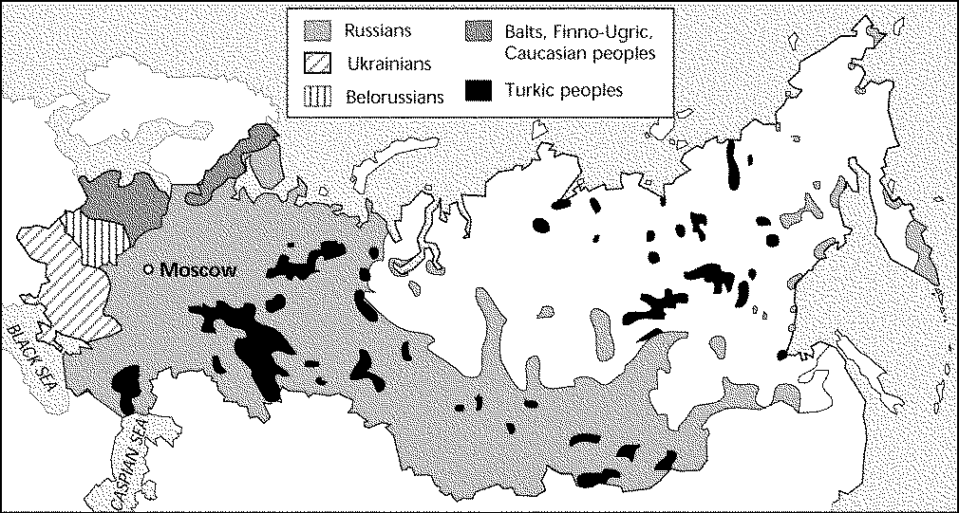
Question 8: What does this map show about Russia in the 1800s?
Russian Absolutism
For centuries, Russian czars ruled with absolute power. When Alexander I inherited the throne of Russia in 1801, he was open to liberal ideas. When Napoleon invaded Russia in 1812, Alexander drew back from reform for fear of losing the support of the nobles.
When Alexander I died in 1825, a group of army officers led an uprising known as the Decembrist Revolt. They demanded a constitution and other reforms. The new czar, Nicholas I, suppressed the Decembrists and cracked down on revolts. Nicholas used police spies to hunt out critics of his rule. He banned books that spread liberal ideas. Many Russians with liberal or revolutionary ideas were judged to be insane and shut up in mental hospitals. Nearly 150,000 people were exiled to Siberia.
Nicholas I embraced three pillars of Russian absolutism: “Orthodoxy, Autocracy, and Nationalism”. Orthodoxy meant strong ties to the Russian Orthodox Church. Autocracy was the absolute power of the state. Nationalism involved respect for Russian traditions and suppression of non-Russian groups.
What did Czar Nicholas I do to retain absolute power?

Reforms of Alexander II
Alexander II came to the throne in 1855, during the Crimean War. The war broke out after Russia tried to seize Ottoman lands along the Danube River. Britain and France stepped in to help the Ottomans, invading the Crimean peninsula that juts into the Black Sea. The war ended in Russia’s defeat and exposed its backwards society. Widespread reaction followed the Crimean War.
Liberals demanded changes, and students demonstrated for reform. Pressed from all sides, Alexander II agreed to reforms. In 1861, he issued a royal decree that required emancipation, or freeing, of the serfs. Freedom brought problems for the serfs. They had to buy the land they had worked on but many could not afford to do so. As a result, many peasants remained poor and discontented. Some former serfs were able to move to cities, take jobs in factories, and help build up Russian industry.
Alexander II also set up reforms for local government. He created elected assemblies, called zemstvos, which were made responsible for matters such as road repair, schools, and agriculture. At the local level, Russians gained some self-government.
Who was the Russian czar who freed the serfs?
Reaction to Change
In the 1870s, some socialists carried the message of reform to peasants by living and working amongst them and preaching rebellion. Some socialist radicals turned to terrorism. A revolutionary group calling itself the “People’s Will” assassinated officials and plotted to kill the czar. In March 1881, terrorists hurled two bombs at Alexander II’s carriage and assassinated the czar.
Alexander II’s son and successor, Alexander III responded by reverting back to the harsh methods of Nicholas I. The czar launched a program of Russification aimed at suppressing the cultures of non-Russian people within the empire. There was one language (Russian) and one church (the Russian Orthodox Church).
The czar limited the number of Jews allowed to study in universities and work certain positions. He forced Jews to live in certain restricted areas. Official persecution encouraged pogroms, or violent mob attacks on Jews. Gangs beat and killed Jews and looted and burned their homes and stores. The police did nothing to stop the violence. Many Jews escaped from Russia.
What happened to Alexander II?
Building Russian Industry
Under Alexander III and his son, Nicholas II, Russia entered the Industrial Age. In the 1890s, finance minister Count Serge Witte focused on economic development. Witte encouraged railroad building to connect iron and coal mines with factories and to transport goods across Russia. Loans from France helped build the Trans-Siberian Railroad which linked European Russia to the Pacific Ocean.
Industrialization caused certain problems. Government officials and business leaders applauded and encouraged economic growth. Nobles and peasants opposed it, fearing the changed brought by the new ways. Peasants flocked to cities to work in factories amongst dangerous conditions.
Radicals sought supporters among the new industrial workers. Socialist handed out pamphlets that preached the revolutionary ideas of Karl Marx. Among the revolutionaries was Vladmir Lenin.

Question 15: What steps did Russia take to enter into the Industrial Age?

Question 16: What was the impact of Russian industrialization?
Turning Point: Crisis and Revolution I
War broke out between Russia and Japan in 1904. Nicholas II called on his people to fight for “the Faith, the Czar and the Fatherland.” Despite their efforts, Russians continued to suffer defeats. News of the military defeats unleashed discontent in Russia. There were many protests and workers’ strikes calling for a constitution, reforms for workers, and government reforms.
A young Orthodox priest, Father George Gapon, organizaed a march for Sundary, January 22, 1905. Father Gapon and the parade marched through St. Petersburg toward the czar’s Winter Palace.
Fearing the marchers, the czar fled the palace and called in soldiers. Seeing the soldiers, the parade turned violent. The slaughter of men and women marked a turning point for Russians. The “Bloody Sunday” killed the people’s faith and trust in the czar.

What event led to discontent in Russia in the early 1900s?

What happened on “Bloody Sunday”?

Turning Point: Crisis and Revolution II
In the months that followed “Bloody Sunday”, discontent exploded across Russia. Peasants and workers revolted. Nicholas was forced to announce sweeping reforms. In the October Manifesto, he promised “freedom of conscience, speech, assembly and union.” He agreed to summon a Duma, or elected national legislature.
The Manifesto won over moderates, leaving socialists isolated. In 1906, the first Duma met, but the czar dissolved it when leaders criticized the government. Nicholas then appointed a new prime minister Peter Stolypin. Arrests, pogroms, and executions followed as the conservative Stolypin tried to restore order.
Stolypin soon realized that Russia needed reform, not just repression. He introduced moderate land reforms. He strengthened the zemstvos and improved education. These reforms were too limited to meet the broad needs of most Russians, and dissatisfaction continued. Stolypin was assassinated in 1911. Several more Dumas bet during this period, but new voting laws made sure they were conservative.
What was the Duma?

What reforms did Peter Stolypin make?

